The Wildlife Trust of South and West Wales
Ymddiriedolaeth Natur De a Gorllewin Cymru

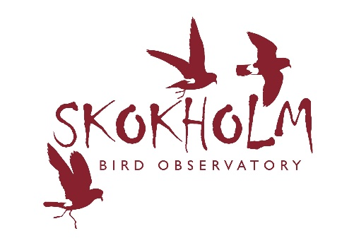
To be returned to:
Giselle Eagle and Richard Brown
Email: skokholmwarden@gmail.com
Post: Wildlife Trust of South and West Wales
Welsh Wildlife Centre
Cilgerran, Cardigan, SA43 2TB
Skokholm Island
Long-term Volunteer Placement 2024
Application Form
Confidential

Personal Details
Forename
Surname
Date of Birth
Address
Postcode
Telephone Number
E-mail Address
- Do you hold a full UK Driving License? | Yes ☐ | No ☐
- If Yes do you have any current endorsements? | Yes ☐ | No ☐
If Yes to question 2, please provide details below

Please specify your preferred placement:
☐1st April 2024 to 1st July 2024
☐1st July 2024 to 30th September 2024
☐Either placement

- Do you have any convictions which are not yet spent under the Rehabilitation of Offenders Act 1974? | Yes ☐  No ☐
We regret that we cannot accept applications from individuals with spent or unspent convictions for violent or sexual offences.  Do you have any spent or unspent convictions for violent or sexual offences? | Yes ☐  No ☐

Past Volunteer and/or Employment details
Please list any previous volunteering or paid work which you have done which is relevant to the role of Skokholm Long-term Volunteer.

Name and Address of Organisation | Position | Date From | Date To | Duties

Qualifications
Please list the qualifications you have that are relevant to this application (e.g A-Level, BTEC National, Degree)
Type of Qualification | Subject | Result and Assessment Date

Training Courses
Detail any relevant training you have received or any relevant short courses attended (e.g., BTO Ringing License, First Aid)

Why do you want to be a Skokholm Long-term Volunteer?
Tell us what it is about this post that appeals to you and what you could bring to the role

How do you feel this role will benefit your dream career?
Tell us where you see yourself in five years

What’s your best wildlife experience?
Tell us something about your most memorable wildlife encounter

Your spare time interests and vocational activities
Tell us about your hobbies

What’s your favourite seabird and why?
Be brutal, pick one!

References
Please give contact details of two people that can supply a reference for you
Name
Address
E-mail
Telephone Number
Relationship

Name
Address
E-mail
Telephone Number
Relationship

Signature

Date

